
CSA15 Cloud Computing and Big Data Analytics
Presenter Details
Student Name: G . Mounika RegisterNumber:192372110 Class / Section / Slot: B
Capstone Title: Cloud-Based crop water AI: Irrigation scheduling and water stress
Selected SDG Goal(s): Clean water and Sanitation.
Cloud Platform / Tools: Zoho,python,REST API,Github

Capstone Cloud Technical Presentation
Individual Student Presentation Deck


Presentation Focus
Present your capstone as a cloud-backed product. Explain the problem, architecture, service choices, evidence, and CO1 learning clearly.

Guidance - delete before presentation: Fill presenter details, then delete this orange guidance tab from every slide before final submission.

Problem Context and Stakeholder Mapping

Our capstone begins with a real problem to solve


Problem Statement
Traditional irrigation often causes water wastage and crop water stress due to the lack of real-time monitoring. A cloud-based AI system enables smart irrigation scheduling, water stress prediction, and efficient water management.
Target Users
Farmers , Agricultural Managers , Irrigation Engineers Government Agriculture Departments
Benefits: Smart irrigation, water saving, higher crop yield, real-time monitoring.



SDG Fit
SDG 2: Zero Hunger
SDG 6: Clean Water and Sanitation
SDG 13: Climate Action
• SDG 15: Life on Land
Product Boundary
User Login ,Crop & Field Management , Soil Moisture Monitoring AI Water Stress Detection , Smart Irrigation Scheduling Cloud Storage & Dashboard

Guidance - delete before presentation: Keep the slide short. Present the problem orally with one example, not a long paragraph.


Cloud Adoption Rationale and Concept Map
Cloud Characteristics
Elasticity, scalability, measured service, resource pooling.


The problem needs cloud support to become a usable product
Cloud Definition
A cloud-based system stores and manages medicine inventory online, enabling secure, real-time access from anywhere.
Cloud Concept Map

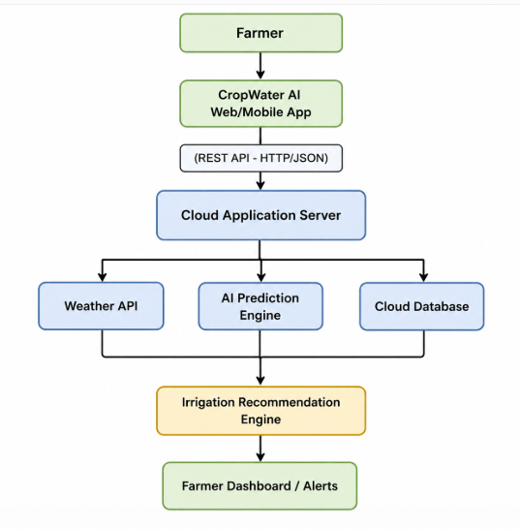

Guidance - delete before presentation: Use the concept map as a speaking aid. Do not overload it with tiny text.

Capstone Cloud Architecture

Our cloud architecture connects the user action to services

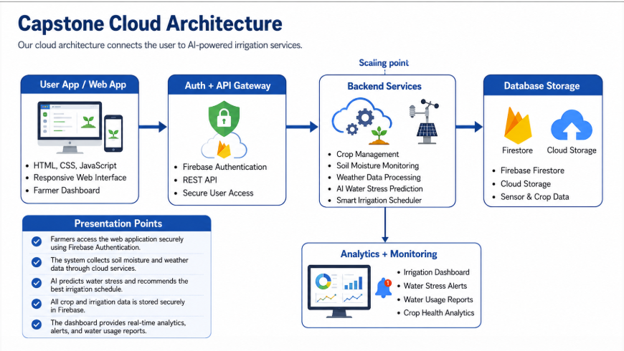

Cloud Service Model Responsibility Matrix

Each service model defines what we control and what cloud manages

Service areaModel Provider manages Student team manages Why this fits
Frontend hosting | PaaS | Firebase Hosting | HTML, CSS, JavaScript UI | Fast and secure web hosting
Backend/API | PaaS | Firebase Cloud Functions / API | AI irrigation logic & API integration | Reduces server management
Database | PaaS | Cloud Firestore | Crop, soil moisture & weather data | Real-time cloud database
Storage | PaaS | Firebase Storage | Sensor data, field images & reports | Secure cloud file storage
Monitoring / logs | PaaS | Firebase Console | Dashboard, alerts & performance monitoring | Tracks application performance
Security / IAM | PaaS | Firebase Authentication | User login & access control | Secure login and user management

Guidance - delete before presentation: Mention only services that fit your capstone. Defend responsibility split orally.

Data Flow and Analytics Pipeline
The product data moves from user activity to useful insight

Visualize
Farmer dashboard
Irrigation schedule
Water stress alerts

Process
AI Water stress prediction
Weather analysis

Ingest
Web application
Firebase auth
IOT sensor data
API Request

Store
Cloud Firestore
Firebase storage
Sensor & crop data

Collect
Soil moisture data
Weather data
Crop details
Farmer inputs

Proof Required

Crop: Paddy
Soil Moisture: 28%
Water stress: Medium
Recommended Irrigation: 20mm
Weather: No Rain Excepted
Status: Irrigation Schedule successfully

Analytic Requirement

Water stress prediction
Irrigation recommendation
Soil moisture trends
Weather forecast analysis
Water consumption reports

Data requirements

Soil Moisture
Temperature
Humidity
Rainfall
Crop type
Field location
Growth stage

Python / AI Module Integration

Python or AI adds intelligence where the product needs it




Python Role
AI Water Stress Prediction ,Smart Irrigation Scheduling , Weather Forecast Analysis ,Water Usage Analytics
Input and Output
Input:
Soil Moisture Temperature
Output:
- Water Stress Level
- on
- Water Usage Report
- Farmer Alerts

Execution Point
Python (Flask/FastAPI) ,Firebase Cloud Functions ,REST API Integration ,Scheduled AI Prediction
Product Value
Reduces Water Wastage , Improves Crop Yield , Detects Water Stress Early , Saves Water through AI , Supports Smart Farming

Guidance - delete before presentation: If AI is not needed, present a Python automation or analytics component.

Security, Scalability, Privacy and Cost Design

Security, scale, privacy and cost shape the final design


Security
Firebase Authentication, Role-Based Access, Data Encryption, secure cloud storage
Privacy
Authorized User Access, Secure farmer data, Data Confidentiality, Privacy Protection



Scalability
Automatic Cloud Scaling, Supports Multiple Farms, Realtime Data Processing, High Availability
Cost Awareness
Firebase Free Tier, Pay-as-you-go Pricing, Low Maintenance Cost, Cloud based Infrastructure

Guidance - delete before presentation: Present decisions, not generic definitions. Tie every point to the capstone.


Implementation Stack and Deployment Evidence
Version Control
Git, GitHub, Branch Management, README Documentation


Our implementation stack shows how the design will be built
Cloud Services
Firebase Authentication, Cloud Firestore, Firebase Hosting, REST API

Mobile / Web Login page

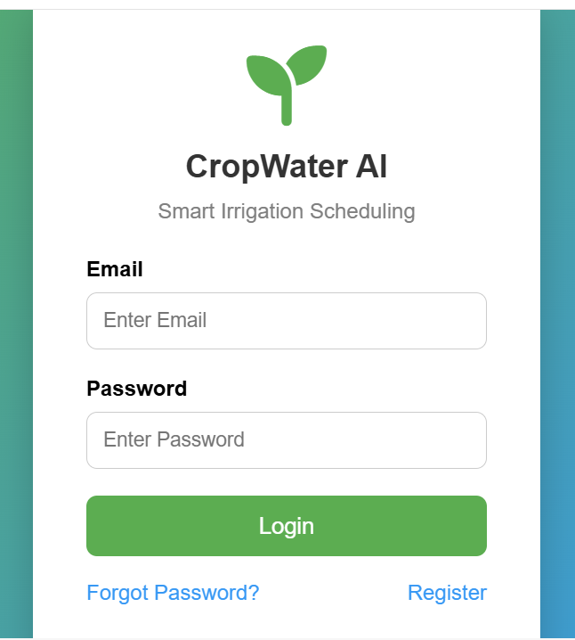

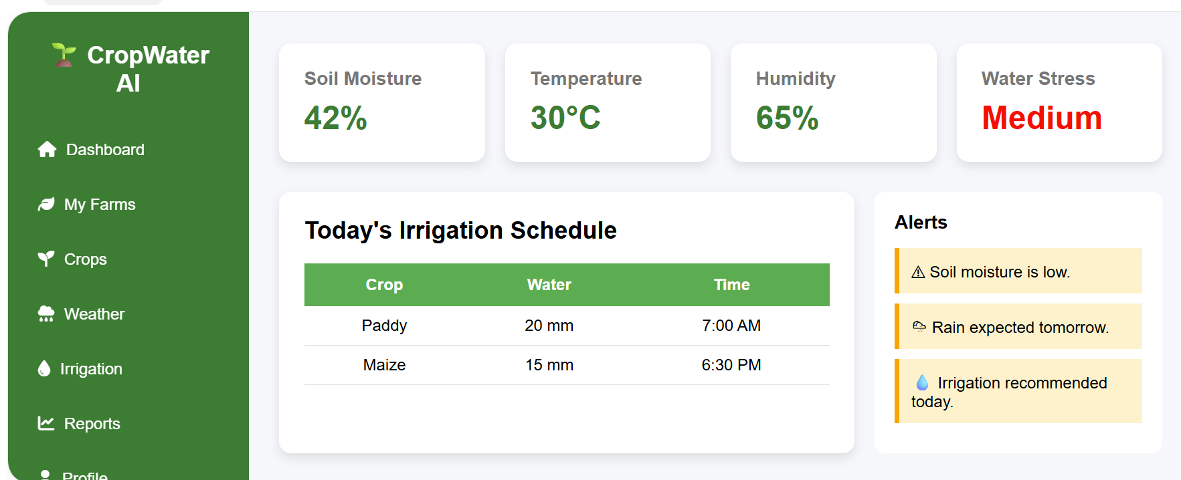

Guidance - delete before presentation: Show real evidence. One clear screenshot is better than many unreadable screenshots.

Demo Storyboard and User Journey

A complete user journey proves the product flow



Scene 1
User logs into the system using Firebase Authentication
Scene 2
Farmer enters crops,soil moisture, and weather details

Scene 3
Data is securely stored in firebase cloud Firestore




Scene 4
AI predicts water stress and generates irrigation recommendations.
Scene 5
Farmer views dashboard with irrigation schedule and alerts.
Scene 6
Reports are generated and irrigation decisions are updated successfully.

Guidance - delete before presentation: Show the product journey. Each scene should connect user action, system response, and cloud component.

Evaluation Readiness Checklist

Our evidence confirms that the presentation is ready
Cloud ecosystem and service model explained
Elasticity and scalability decisions are visible
REST/SOAP/API role connected to capstone
GitHub and cloud evidence are inspectable
Architecture has compute, data, storage, security, monitoring
References and integrity statement are included

Guidance - delete before presentation: Use this as a self-check slide while preparing. Delete the guidance tab before presentation.
Evaluator Focus
CO1 is verified through cloud design reasoning, service choices, evidence, and individual explanation.

Conclusion, Limitations and Future Scope

We close with learning, limitations and next steps


Learning Outcome
Cloud Computing, Firebase Services, AI-Based prediction,Smart IrrigationSystem
Limitations
Internet Dependency, Sensor Availability, Limited AI Features, Free Tier Restrictions



Future Improvement
IOT Sensor integration, Mobile Application , Satellite weather integration, Advanced AI Prediction
Integrity Statement
Developed using Firebase, HTML, CSS, JavaScript, Python, GitHub, ChatGPT (for guidance), with proper academic integrity maintained.

Guidance - delete before presentation: End with technical learning, not only a thank-you slide.

